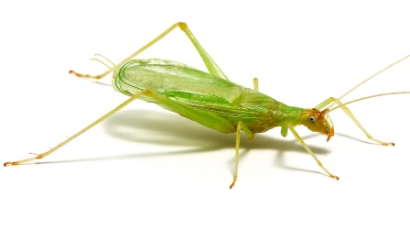
3.2 Lesson Notes
The Snowy Tree Cricket!

One of the more familiar late-evening sounds during the
T, Temperature ($℉$) | N, Number of chirps/minute
55 | 60
60 | 80
65 | 100
70 | 120
75 | 140
80 | 160

summer is they rhythmic chirping of a male cricket.
Of particular interest is the snowy tree cricket, sometimes
called the temperature cricket. It is very sensitive to
temperature, speeding up or slowing down its chirping as
the temperature rises or falls. The following data shows
how the number or chirps per minute of the snowy
tree cricket is related to temperature.

GROUPS:
1. Crickets are usually silent when the temperature falls below $55°$. What is a possible practical domain for the snowy tree cricket function?

2a. Determine the average rate of change of the number of chirps per minute with respect to the temperature as the temperature increases from $55°$F to $60℉$.

2b. What are the units of measure of this rate of change?

3. How does the average rate of change determined in Problem 2 compare with the average rate of change as the temperature increases from $65°$F to $80℉$.

SLOPE of Line:
Brainstorm items that come to mind when you hear the word SLOPE.
Write as many as you can think of.

GROUPS:
4. What is the slope of the line in the snowy tree cricket situation?

5. Because the slope of this line is positive, what can you conclude about the direction of the line as the independent variable (temperature) increases in value?

6. What is the meaning of slope in this situation?

7. Select any two points from the table of the snowy tree crickets. Determine the slope between those two points.

(Compare group answers.)

