3.5 Lesson Notes
Housing Prices

Suppose a steady increase in housing prices has occurred in your neighborhood since 1995. The house across the street sold for $125,000 in 1998, and then sold again in 2002 for $150,000. This data can be written in a table, where x represents the number of years since 1995 and y represents the sale price of a typical house in your neighborhood.
Number of years since 1995, x | House Price (thousands of $), y
3 | 125
7 | 150

b. Plot the two points on the grid below, and sketch the line containing them. Extend the line so that it intersects the y-axis. Scale the x-axis to include the period of years from
1995 to 2005 (from x = 0 to x = 10). Scale the y-axis by increments of 25,
starting at 0 and continuing through 250.

2a. Use the points in the table to determine the slope of a line. What are its units of measurement?

b. What is the practical meaning of the slope in this situation?

3. Estimate the y-intercept from the graph. What is the meaning of this intercept in this situation?

4a. Use the slope and your estimate of the y-intercept to write a linear equation for house price, y, in terms of x, the number of years since 1995.

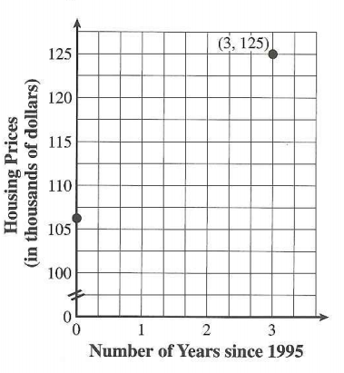
5a. Starting at the point (3, 125), use the slope $\frac{6.25}{1}$ to determine the coordinates of the y-intercept.

b. How does the result in part a compare to the estimate of the y-intercept you obtained in Problem 3?

6a. There is also an algebraic way of finding the equation of the line through two points. Using (3, 125) and (7, 150) from the initial table, find the equation algebraically of the line that goes through both of these points.

b. Verify your equation using your calculator. How do you know you found the correct equation using your calculator?

EXPLAIN:
Summarize how you would find the equation of a line when you are given two points. Then explain how you would use that line to find the y-intercept.

