3.6 Lesson Notes Linear Correlation
Scatterplots
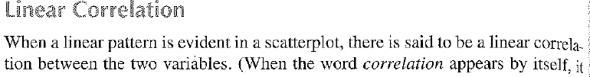
*
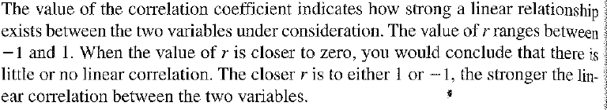
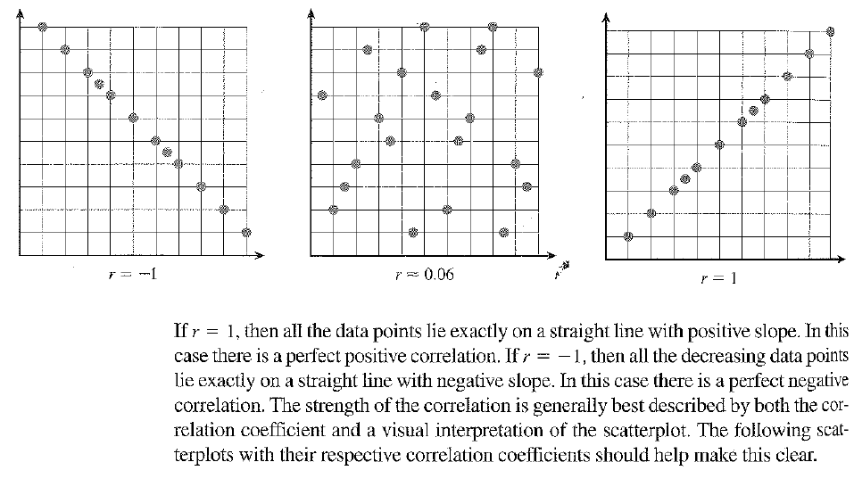

Negative Correlation samples
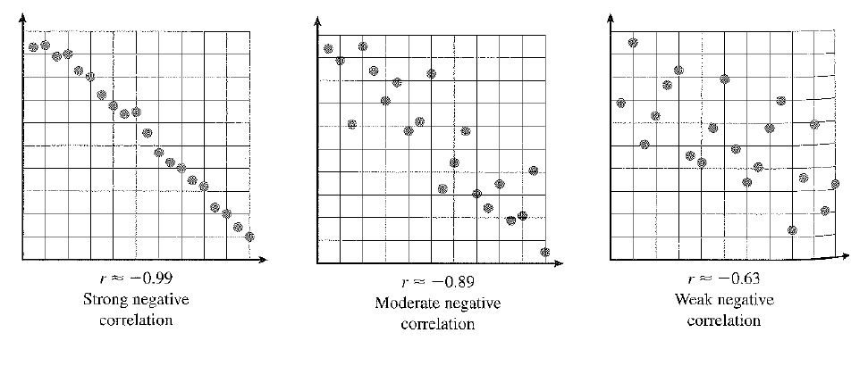
Positive Correlation Samples
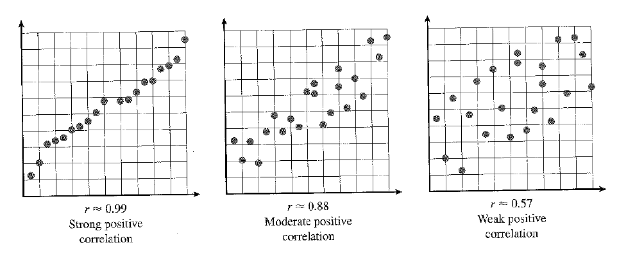
Matching
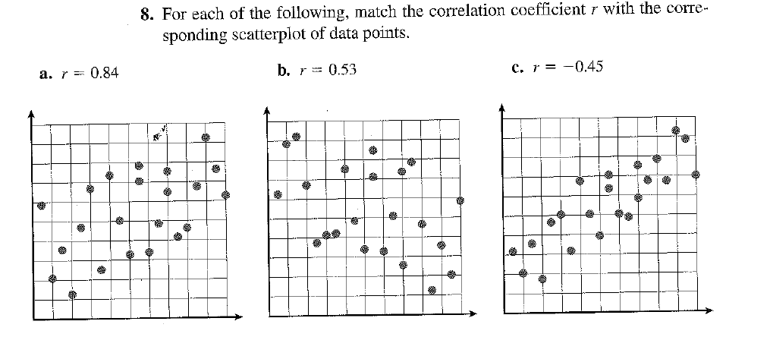
Describe in words each scatterplot as strong, weak, moderate, positive or negative.
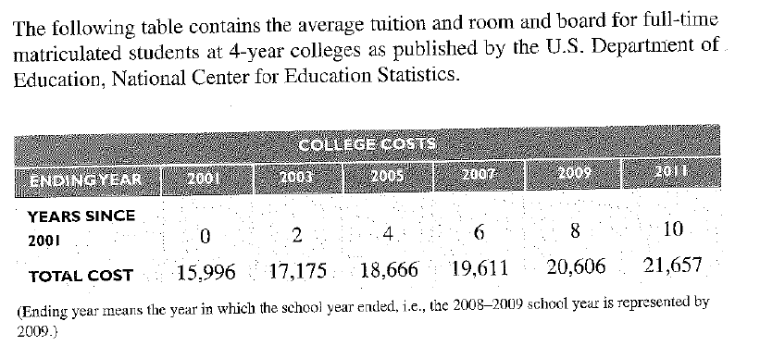
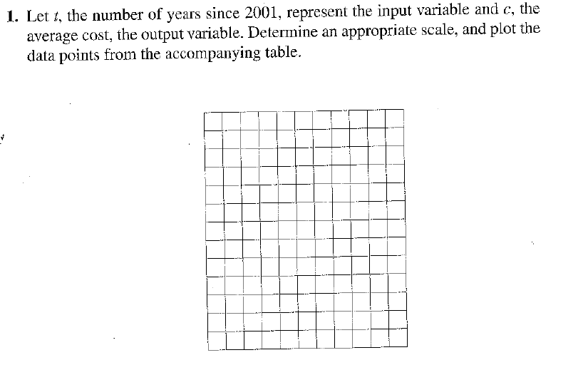
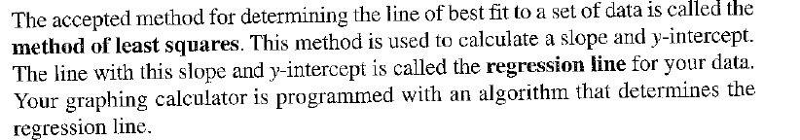

First, we must program our calculator to calculate the “r” correlation coefficient value. To do this, we need to follow these steps.
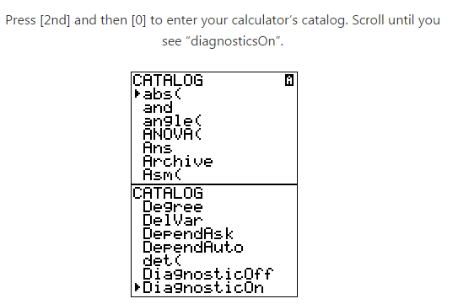
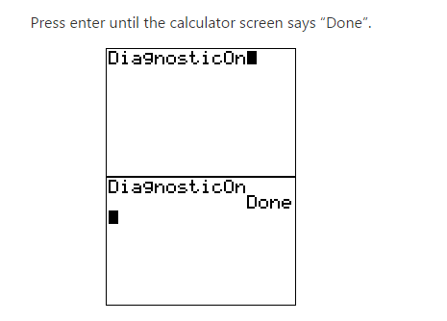
That’s it. You won’t have to do this again unless your calculator is reset.
Now.., we’re going to edit our L1 (x) and L2 (y) values in the calculator.
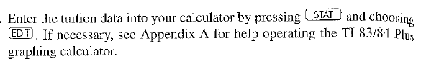
Hit 2nd “QUIT” after you’ve entered the Lists.
Now turn on your “STAT PLOT”. 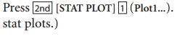
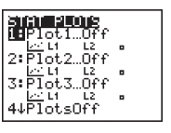
Press “Enter” and make sure your stat plot screen looks like this –
Next.., we need to adjust our window. Make sure your window values are set as follows: Press the “WINDOW” button:
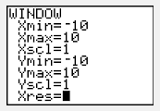
After you have adjusted the “WINDOW” values, hit 2nd “QUIT” to get back to a blank screen.
Now tap the “GRAPH” button and take a look at the scatter plot. It should look similar to this.
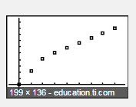
Hit 2nd “QUIT” for a blank screen.

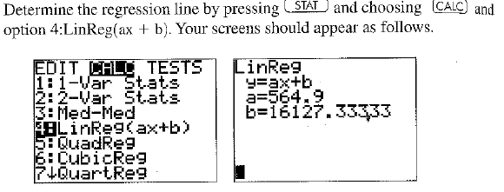
What is the correlation coefficient or “r” value on your screen? How can we describe the meaning of the “r” value? In other words is it: strong, weak, moderate, positive, negative – choose all that apply.

Write the equation of the line in y=mx+b form. Here the “a” value from the screen equals “m” and the “b” value is the y-intercept.

Now put the equation into the “Y=” screen of our graphing calculator and graph the best fit line. Sketch a picture in the screen below.
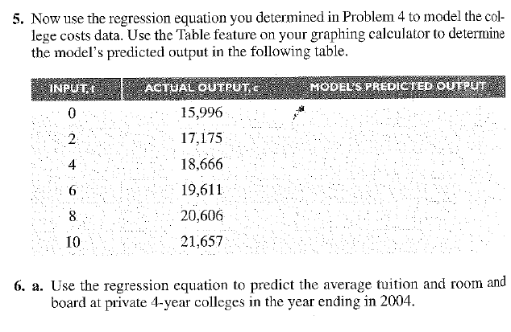

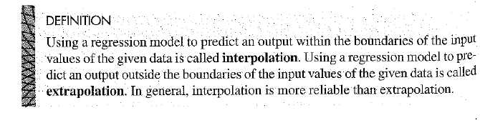

e. If you graduate from high school in 2018 and enter a 4 year college in the fall of 2018 and matriculate through (spend all 4 years in college); what would be the total cost of the 4 years according to the equation model?
2018-2019 Year ( ) 2019-2020 Year ( ) 2020-2021 Year ( ) 2021-2022 Year ( )

_____________ + _____________ + _____________ + _____________= _________________

