6-6 Notes: Systems of Inequalities

- The solution of a system of inequalities is:
________________________________________________________________

- When graphing a system of inequalities, the solution is:
________________________________________________________________

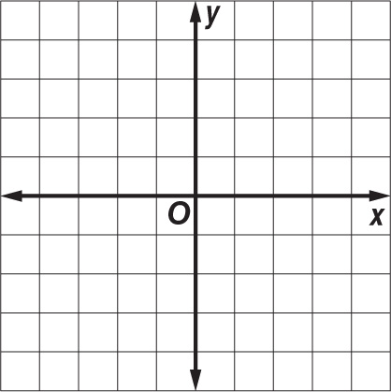
Example 1: Solve the system of inequalities by graphing.
y > x + 2
y ≤ –2x – 1

Example 2: Solve the system of inequalities by graphing.
x + y > 4
x + y < –1

Exercises
Solve each system of inequalities by graphing.
1. y > –1 2. y > –2x + 2 3. y < x + 1
x < 0 y ≤ x + 1 3x + 4y ≥ 12

4. 2x + y ≥ 1 5. y ≤ 2x + 3 6. 5x – 2y < 6
x – y ≥ –2 y ≥ –1 + 2x y > –x + 1

