6-6 Tuesday Homework: Graphing Lines Review

Find the x- and y-intercepts of each linear function.
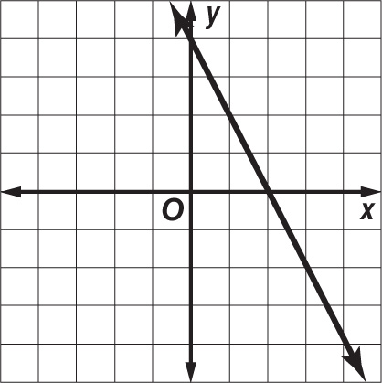
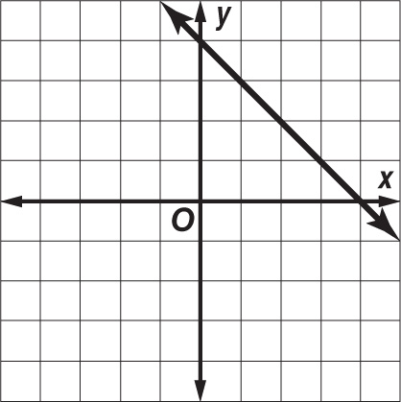
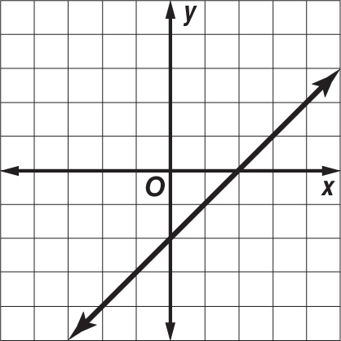
1. 2. 3.

Graph each equation.
4. y = 4 5. y = 3x 6. y = x + 4
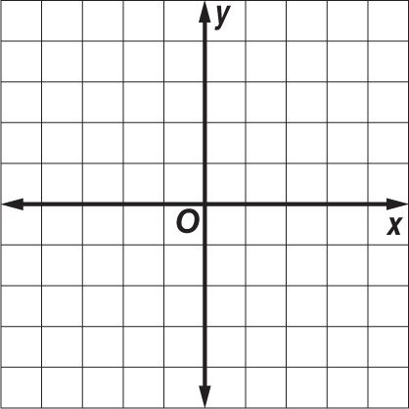

7. x – y = 3 8. 10x = –5y 9. 4x = 2y + 6

