Due Monday January 11th
7-1 Homework: Multiplication Properties of Exponents

Determine whether each expression is a monomial. Write yes or no. Explain your reasoning.
1. $\frac{21a^{2}}{7b}$

2. $\frac{b^{3}c^{2} }{2}$

Simplify each expression.
3. (2a$b^{2}f^{2}$)(4$a^{3}b^{2}f^{2}$) 4. (4$g^{3}$h)(–2$g^{5}$)

5. (–15x$y^{4}$)$\left(-\frac{1}{3} xy^{3}\right)$ 6. ${(-18m^{2}n)}^{2}\left(– \frac{1}{6}mn^{2}\right)$

7. ${\left( \frac{2}{3}p\right)}^{2}$ 8. ${\left( \frac{1}{4}ad^{3}\right)}^{2}$

GEOMETRY Express the area of each figure as a monomial.
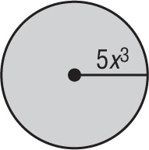
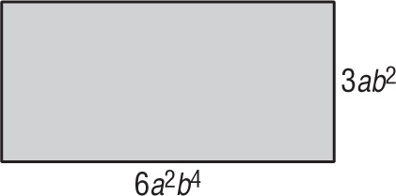
9. 10.

Write in Scientific Notation
11. 5,100,000 12. 80,300,000,000 13. 14,250,000

14. 68,070,000,000,000 15. 14,000 16. 901,050,000,000

