7-5 Homework: Exponential Functions

Graph each function. Find the y-intercept, and state the domain and range.
1. y = $2^{x}$ 2. y = ${\left(\frac{1}{3}\right)}^{x}$
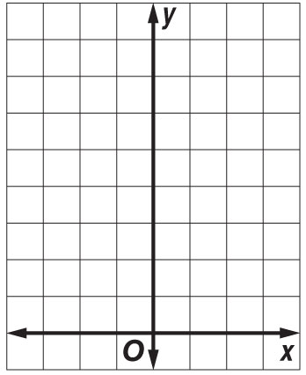
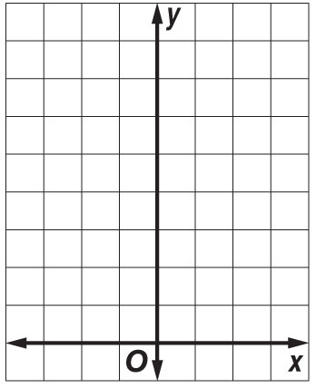

3. y = 3($2^{x}$) 4. y = $3^{x}$ + 2

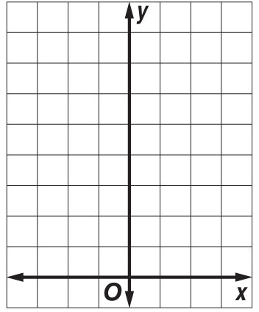
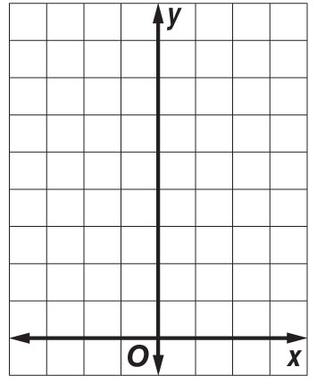

Determine whether the set of data shown below displays exponential behavior. Write yes or no.
Explain why or why not.

5. | x | –3 | –2 | –1 | 0
 | y | 9 | 12 | 15 | 18

6. | x | 0 | 5 | 10 | 15
 | y | 20 | 10 | 5 | 2.5

